

**T.E. MINI PROJECT REPORT**

**On**

**“Maximum Power Point Tracker with Controllable Opto-isolated Solid-state outputs and function driven status display”**

Submitted by

Advait Thale Exam No:-T190453143

Mansi Veer Exam No:-T190453148

UNDER THE GUIDANCE OF

**Prof. Jitendra Bakliwal (Internal Guide)**

IN PARTIAL FULFILLMENT OF

T.E. (ELECTRONICS & TELECOMMUNICATION) SAVITRIBAI PHULE PUNE UNIVERSITY

2021-2022

MARATHAWADA MITRA MANDAL’S COLLEGE OF ENGINEERING, PUNE- 52

DEPARTMENT OF ELECTRONICS AND TELECOMMUNICATION



MARATHAWADA MITRA MANDAL’S

**COLLEGE OF ENGINEERING, PUNE**

**CERTIFICATE**

This is to certify that the Mini Project Report entitled

**“Maximum Power Point Tracker with Controllable Opto-isolated Solid-state outputs and function driven status display”**

Submitted by

Advait Thale Exam No:-T190453143

Mansi Veer Exam No:-T190453148

is Bonafede work carried out by them under the supervision of Prof. Mr..Jitendra Bakliwal and it is approved for the partial fulfilment of requirement of Savitribai Phule Pune University for award of the degree of Bachelor of Engineering (Electronics and Telecommunication).

This seminar report has not been earlier submitted to any other Institute or University for the award of any degree or diploma.

Mr. Jitendra Bakliwal Dr. G. S. Gawande Dr.V. N. Gohokar

Project Guide Head of Department Principal

Department of E&TC Department of E&TC MMCOE

Place: Pune

Date:

**INDEX**

**Abstract**

**List of Figures**

1. **Chapter 1 07**
   1. Introduction 08
2. **Chapter 2 10**
   1. Literature Survey 11
3. **Chapter 3** **13**
   1. System Specifications 14
   2. Block Diagram 14
4. **Chapter 4 16**
   1. Hardware Implementation 17
   2. System Schematic and Circuit Diagram 19
   3. PCB Artwork 20

4.4 3D Render 21

1. **Chapter 5 24**
   1. Practical Implementation 25
2. **Chapter 6** **27**
   1. Conclusion… 28
   2. Future Scope 28
   3. Schedule 26

**REFERENCES**

**LIST OF FIGURES**

|  |  |  |  |
| --- | --- | --- | --- |
| **Sr. No.** | **Name of Figure** | | **Page No.** |
| 3.1 | Block Diagram | | 14 |
| 4.1 | ESP32 Dev Module | | 17 |
| 4.2  4.3 | Circuit Diagram  PCB Layout of Main Board | | 19  20 |
| 4.4 | PCB Layout of LCD Daughterboard | | 20 |
| 4.5 | Top View of Main Board | | 21 |
| 4.6 | Isometric View of Main Board | | 21 |
| 4.7 | Back View of Main Board (Routes) | | 22 |
| 4.8 | Front view of LCD Daughterboard (Routes) | | 23 |
| 4.9 | Back view of LCD Daughterboard (Routes) | | 23 |
| 5.1 | Initialization on LCD | | 25 |
| 5.2 | Parameters on LCD | | 26 |
|  | |

**ABSTRACT**

The abstract focuses on controllable Maximum Power Point Tracking (MPPT) techniques designed to further enhance the power output of photovoltaic (PV) systems. As solar energy becomes increasingly prominent, optimizing the performance of PV modules through effective MPPT algorithms has become crucial. This abstract provides a concise overview of controllable MPPT techniques and their potential for maximizing PV power generation.

Our aim is to display how much voltage is being generated by photovoltaic panels, current flowing through the batteries or battery bank, temperature of battery bank along with cut-off protection in case of battery overheating, customizable charging, settings menu which will be displayed on character LCD and controlled by KY-040 rotary encoder module and most importantly controlled DC outputs.

**ORGANISATION OF REPORT**

Our project “Maximum Power Point Tracker with Controllable Opto-isolated Solid-state outputs and function driven status display” is thoroughly explained in all the chapters in this report. Planning and organization of this subject has been done with curiosity and as per the given deadline. So, this project gives the entire overview of this subject.

The report is divided into various chapters to understand each aspect of the subject technically and separately.

**Chapter 1:**

Gives a brief introduction of this project. This consists of the introduction and scope of the project, objective of this project.

**Chapter 2:**

Gives brief review of the related Literature and present scenario of proposed system.

**Chapter 3:**

Describes System Schematic & Specification and block diagram with its detailed explanation.

**Chapter 4:**

Describes the implementation of the project with its hardware and software description that is detailed analysis of each component.

**Chapter 5:**

Describes the implementation of small modules and algorithms used in projects. Shows the results and observations.

**Chapter 6:**

Describes Semester wise planning and management.

**CHAPTER 1**

**INTRODUCTION**

**1.1 INTRODUCTION:**

The integration of maximum power print tracking (MPPT) techniques with controllable opto-isolated solid-state outputs presents a promising solution for enhancing the efficiency and performance of power conversion systems and also represents a compelling research area that holds significant potential for enhancing the efficiency, reliability and safety of power conversion systems in various applications. This project aims to explore the advancements in this area and provide an overview of the current state of the art research and aims to explore the synergistic effects of combining MPPT algorithms, quasi-resonant topologies and hardware-controlled opto-isolated AC outputs, with a particular focus on their impact on system performance and functionality.

MPPT algorithms plays a crucial role in photovoltaic (PV) systems by dynamically adjusting the operating point of solar panels to extract the maximum power under varying environmental conditions. The integration of MPPT techniques with quasi-resonant topologies offers an opportunity to mitigate switching losses and optimize power transfer, thereby improving the overall efficiency of power conversion systems. Quasi-resonant topologies, characterized by resonant components operating near their natural frequencies, facilitate soft switching and reduce stress on power devices, contributing to enhanced performance and reduced power losses.

Furthermore, a function-driven status display adds value by providing real-time feedback on system performance, fault detection, and diagnostic information. The display acts as a user-friendly interface, allowing operators to monitor the system's operation, identify potential issues, and perform necessary maintenance promptly. This feature facilitates efficient system management, improves reliability, and streamlines troubleshooting processes. This project aims to delve deeply into the theoretical and practical aspects of integrating MPPT techniques, quasi-resonant topologies, and hardware-controlled opto-isolated AC outputs. Through experimental investigations and analysis, the project will evaluate the performance metrics, such as power efficiency, response time, and power quality, to assess the advantages and challenges of this integrated approach. Furthermore, the project will explore control strategies, optimization techniques, and design considerations to maximize the benefits of this integrated system.

The outcomes of this project will contribute to the existing body of knowledge in the field of power electronics, renewable energy, and system integration. The findings will shed light on the feasibility, advantages, and potential applications of combining MPPT techniques, quasi-resonant topologies, and hardware-controlled opto-isolated AC outputs. This knowledge will provide valuable insights for researchers, engineers, and practitioners seeking to optimize power conversion systems, improve renewable energy utilization, and enhance the safety and reliability of electrical systems.

**CHAPTER 2**

**LITERATURE SURVEY**

**2.1 LITERATURE SURVEY:**

As part of our pre-study, we conducted an elaborate literature survey. The literature survey presents an overview on the Maximum Power Point Tracker, Controllable Opto-isolated Solid-state outputs, and function scrolling on LCD. The journals were analysed, and content was presented. After analysing what systems have been published in the journals, we presented our ideas which were focussed on improving the existing system and trying to implement a cost-efficient alternative to existing MPPTs.

After thoroughly classifying every MPPTs available in the market offline as well as online, we came to realize that there exists no display to properly check how much voltage is being generated by photovoltaic panels, current flowing through the batteries or battery bank, temperature of battery bank along with cut-off protection in case of battery overheating, customizable charging, and most importantly controlled DC outputs.

With the help of newly designed IoT based microcontrollers we can achieve the goal of adding above requirements atop of normal MPPT operation improving visibility of work being done. It has emerged as a useful industrial tool for about 25 years and is growing at a higher speed. The applications of newly designed microcontrollers in industries as well as in commercial areas have been typically seen in wireless monitoring, wireless load controlling, various types of automation systems including domestic version as home automation system, remote quality control, remote object sorting, and remote robotic operation and guidance. It has become a yielding tool in product inspection and analysis because it reduces cost, effort, and time with a significant level of accuracy and reliability. With the recent advancement in technology, IoT based microcontrollers can be applied to remotely control as well as monitor various environmental parameters and to collect data from different sensors connected, etc. The application of IoT based microcontrollers has been seen in domestic, medical, industrial, security fields, and in remote monitoring.

We used ESP32 microcontroller for controlling and monitoring all the ongoing operations. We used C, C++ programming languages as the whole ESP program environment is built on them and they are the most efficient programming languages till date for writing libraries and to efficiently compile the program. ESP32 is low cost, SoC single board 32-bit microcontroller with built-in 2.4 GHz Wi-Fi Radio, Bluetooth 4.2 and Bluetooth Low Energy. It can be used to store and display web pages on the PC or smartphone in the browser and the data from the sensors can be viewed in real time. A 16x2 character LCD placed atop the enclosure is used to display the voltage, current and temperature parameters of the battery and produced voltage from PV panels.

**CHAPTER 3**

**SYSTEM SCHEMATIC &**

**SPECIFICATION**

**3.1 SPECIFICATIONS:**

1. 12-24V Photovoltaic Panel Input
2. MOSFET Controlled Output x 2
3. Outputs Controlled by IR Remote
4. Character LCD for Power Status
5. Webserver Access at 192.168.1.1
6. 12V Lead Acid Battery (4V 1AH x 3 in series)
7. Overtemperature Battery Cut-off Protection
8. Port for KY-040 Rotary Encoder for Settings Menu
9. System Alarms through integrated beeper

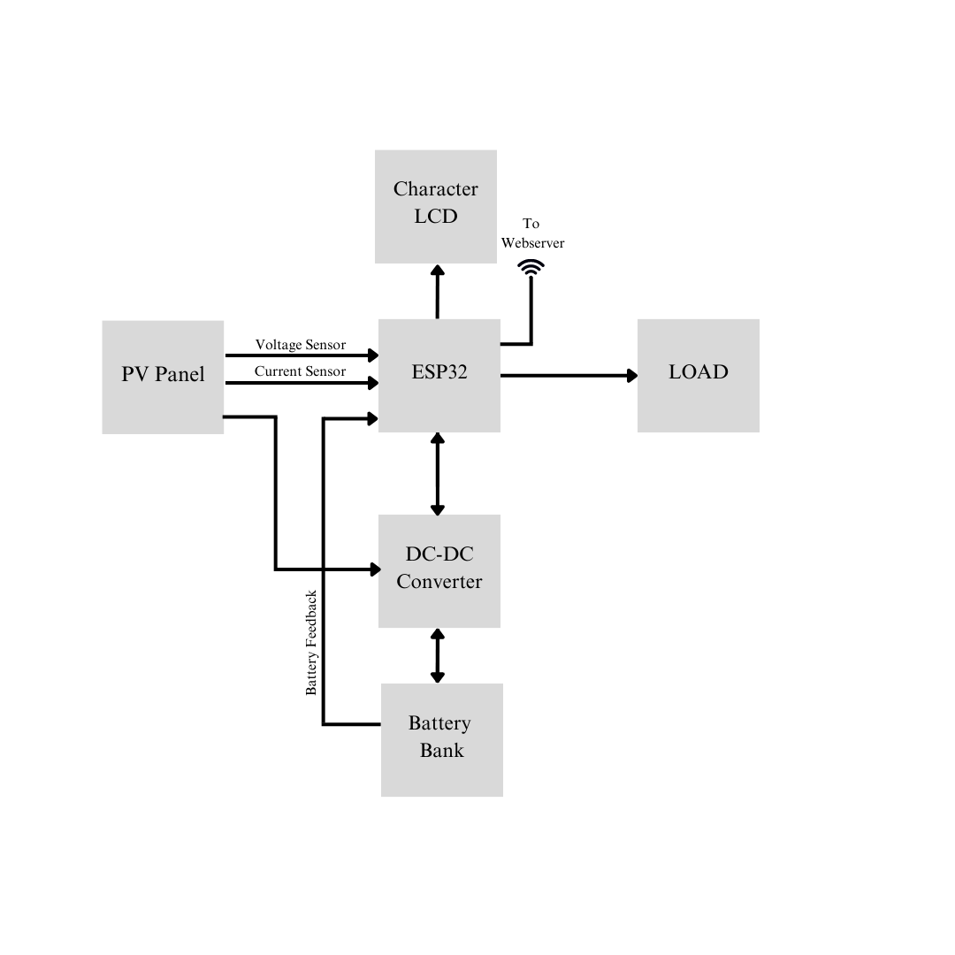 **3.2 BLOCK DIAGRAM:**

Fig. 3.1: Block Diagram of ESP32 Based MPPT with Status LCD

**WORKING:**

The ESP32 is used to control all the important tasks for charging/ using battery bank, to monitor the voltage and current of battery and power generated by PV Panels. The obtained data can be viewed on the character LCD atop of the MPPT enclosure as well as on the webserver in real time. With the help of connected current sensor and ADC, it constantly checks how much voltage is being generated by photovoltaic panels, current flowing through the batteries or battery bank, temperature of battery bank along with cut-off protection in case of battery overheating. The two MOSFET controlled outputs can be used for connecting DC load of 12V Max. The outputs are normally controlled by microcontroller at normal MPPT operations but can be manually controlled by IR remote. If the battery is overheated or is fully charged in those intervals various alerts occur. A header port for KY040 rotary encoder is kept for controlling the output load voltage and battery charge parameters. Also, a header for inverter is routed on the PCB for Inverter daughterboard for further expansion.

**CHAPTER 4**

**CIRCUIT DESIGN &**

**PCB ARTWORK**

**4.1 HARWARE USED:**

* **ESP32:**

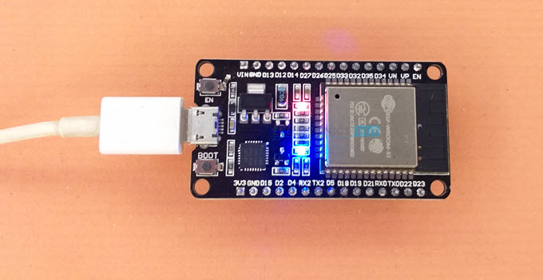

Fig. 4.1: ESP32 Dev Module

An ESP32 is a popular and versatile microcontroller and Wi-Fi/Bluetooth module that is widely used for IOT applications. The ESP32 is powered by a dual core Tensilica Xtensa LX6 microprocessor. Each core operates at a clock frequency of up to 240 MHz.The ESP32 has a significant number of GPIO pins available for connecting external components and sensors. It typically comes with 4MB to 16MB of built-in flash memory for storing firmware and programs. The power consumption of the ESP32 can vary depending on the usage and operating conditions. It offers low-power modes and features to optimize energy efficiency.

* **LM7805:**

The LM7805 is a popular linear voltage regulator IC that provides a fixed output voltage of +5 V. It is widely used in electronic circuits to regulate and provide a stable +5V power supply. The LM7805 requires an input voltage higher than the desired output voltage. It typically operates within a range of 7V to 35V. The LM7805 provides a fixed output voltage of +5V. The dropout voltage is the minimum voltage required between the input and output terminals for the LM7805 to regulate the output voltage properly.

* **116*2 Character LCD:**

A 16*2 LCD (Liquid Crystal Display) is a commonly used alphanumeric display module that can display 16 characters in each of its rows. It is widely used in various electronic projects and devices for displaying information. The 16*2 LCD module is usually based on an HD44789 or compatible controller. This controller handles the interfacing between the microcontroller and the LCD module, providing commands and data for display control. The 16*2 LCD module is usually interfaced with a backlight pin. The most common interface is the 4-bit or 8-bit parallel interface, where data and control signals are sent to the LCD using multiple data lines.

* **4V Lead Acid Battery:**

A 4V lead-acid battery is a type of rechargeable battery commonly used in various applications, including automotive, solar power systems, uninterruptible power supplies (UPS) and other backup power applications. The 4V lead-acid battery is based on a lead-acid chemistry, which consists of lead plates and an electrolyte solution of sulfuric acid (H2SO4). The recommended operating temperature range for lead-acid batteries is typically between -20 °C to 50 °C. Extreme temperatures outside this range can affect the battery’s performance and overall lifespan.

* **2N2222A:**

The 2N2222A is a popular NPN bipolar junctions’ transistor (BJT) commonly used in a wide range of electronic circuits for switching and amplification purposes. The 2N2222A is an NPN (Negative-Positive-Negative) bipolar junction transistor, which means it consists of three layers of semiconductor material: the emitter(N) , base (P) and collector (N). It is designed to control current flow between the collector and emitter terminals using a voltage applied to the base terminal.

* **IRFZ44:**

The IRFZ44 is a popular power MOSFET (Metal-Oxide-Semiconductor Field-Effect Transistor) used for high-power switching applications. It is commonly employed in a variety of electronic circuits, such as motor control, LED lighting, and power supplies. The IRFZ44 is an N-channel MOSFET, meaning it is designed to control the flow of current between the drain and source terminals using a voltage applied to the gate terminal. The IRFZ44 is commonly available in a TO-220 package, which allows for easy mounting and heat dissipation.

* **IR Receiver (VS1838B):**

An IR (Infrared receiver) is a component used to detect and receive infrared signals from remote controls, IR transmitters or other IR sources. It is commonly used in applications such as remote-control systems, home automation and infrared communication. IR receivers typically use a photodiode or phototransistor as the detecting element. These components are sensitive to infrared signals within a specific wavelength range.

**4.2 System Schematic and Circuit Diagram:**

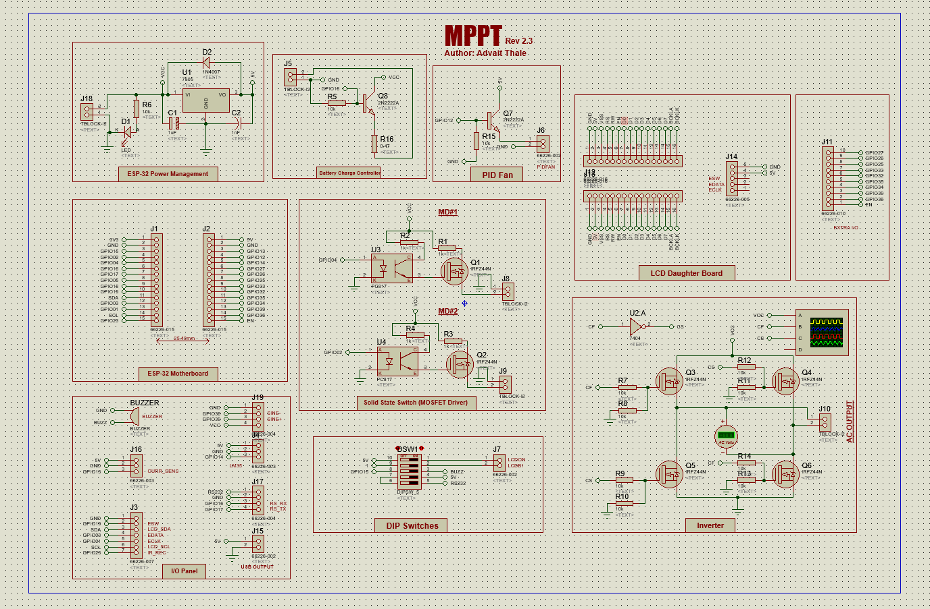

Fig. 4.2: Circuit Diagram

**4.3 PCB Artwork:**

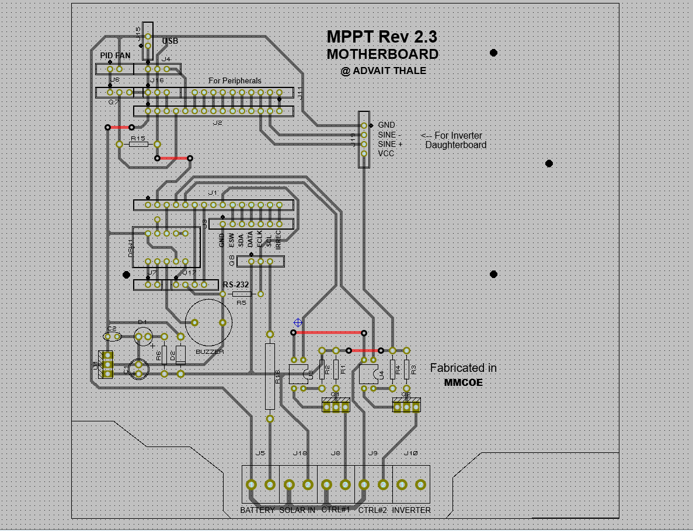

Fig. 4.3: PCB Layout of Main Board

Fig. 4.4: PCB Layout of LCD Daughterboard

**4.4 3D Render of PCB:**

Fig. 4.5: Top View of Main Board

Fig. 4.6: Isometric view of Main Board

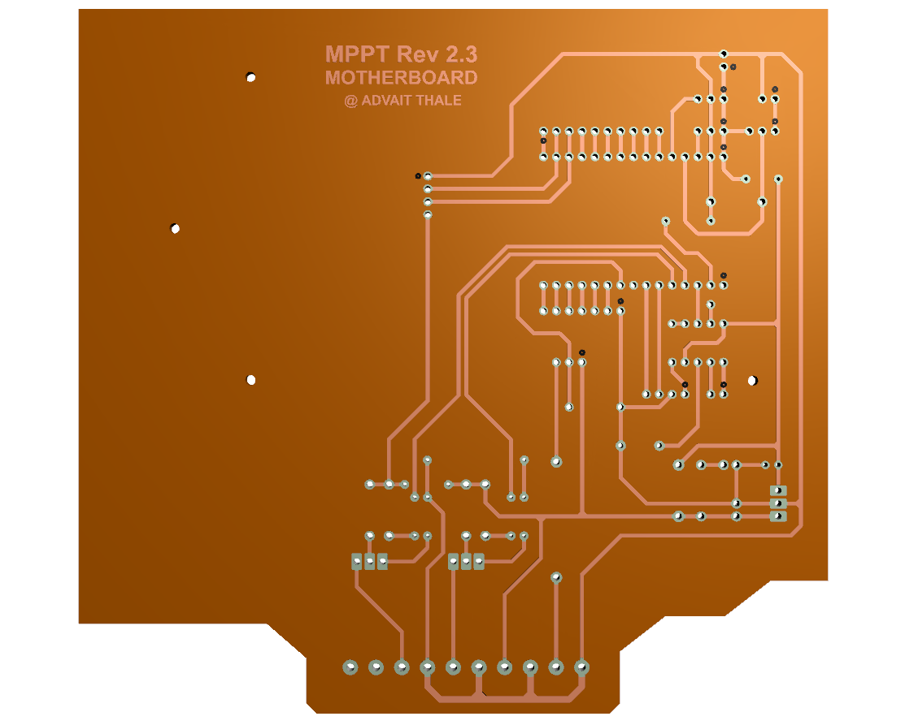

Fig. 4.7: Back view of Main Board (Routes)

Fig. 4.8: Front view of LCD Daughterboard (Routes)

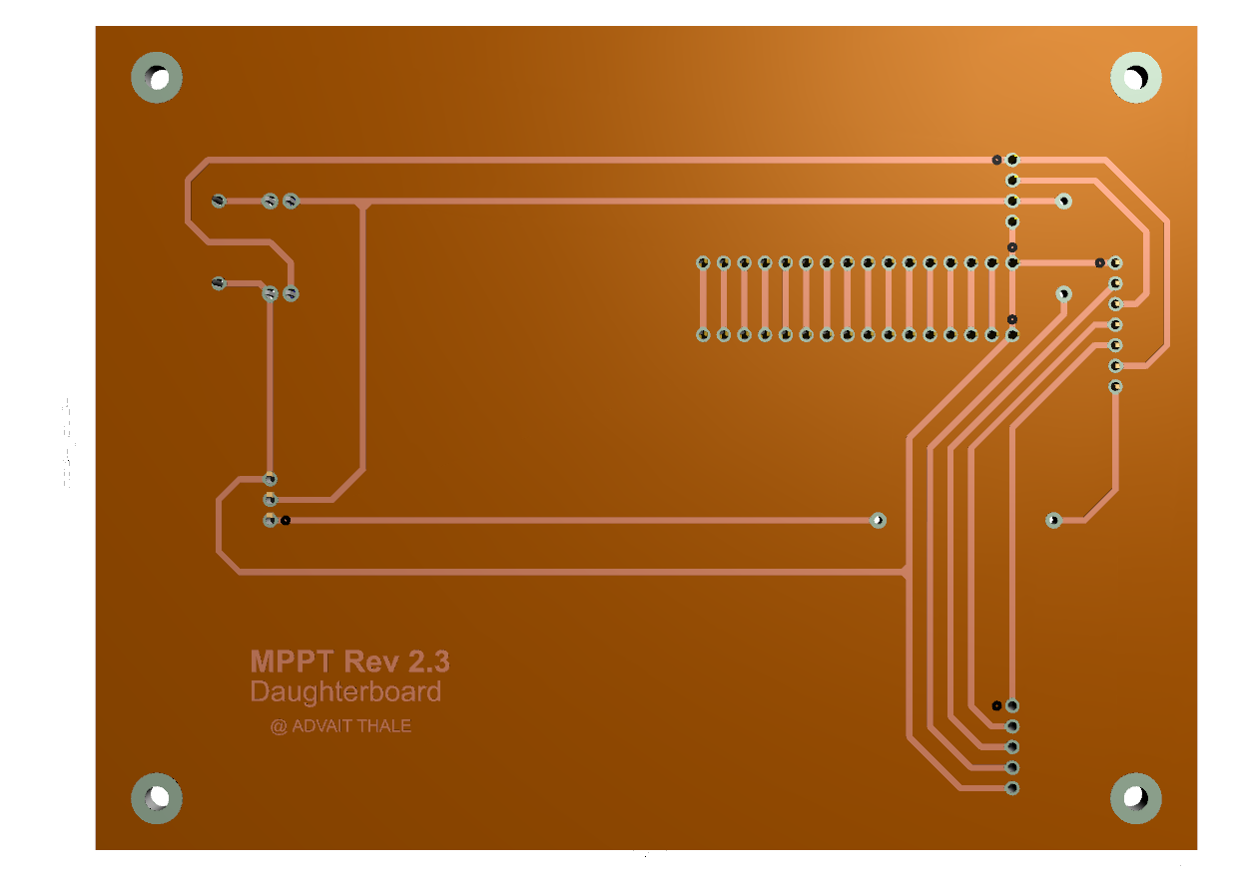

Fig. 4.9: Back view of LCD Daughterboard (Routes)

**CHAPTER 5**

**HARDWARE IMPLEMENTATION**

**5.1 HARDWARE IMPLEMENTATION:**

**CHAPTER 6**

**PROJECT PLANNING &**

**METHODOLOGY**

**6.1 CONCLUSION:**

According to the design and Algorithms proposed in the report we come to a conclusion that the we can automate the detection of products using digital image processing and sorting them using a controller which are passing over the conveyor. We sort the products with high accuracy, good repeatability and high productivity. Using Digital Image Processing in the system we can detect the products based on shape, colour and texture. Further the products are sorted according to its type into different conveyors for packaging

**6.2 FUTURE SCOPE:**

Future work that can be implemented in this project is, we can attach a inverter daughterboard to produce AC output directly from the MPPT with provided connector on PCB thereby increasing productivity of device. We can implement this in other fields by changing simple software and hardware. It can be implemented in domestic as well as commercial areas with few advancements better meet overall power demands.

**6.3 SCHEDULE:**

Week 1 (28-01-23): Group formation and problem statement search.

Week 2 (03-02-23): Project topic finalization.

Week 3 (10-02-23): Problem solving and circuit designing.

Week 4 (17-02-23): Component availability check according to circuits.

Week 5 (24-02-23): Finalizing circuit diagram with available components.

Week 6 (03-03-23): PCB Designing.

Week 7 (10-03-23): Purchased Enclosure and adjusted PCB size.

Week 8 (17-03-23): Finalizing PCB Artwork.

Week 9 (24-03-24): Manufacturing PCB.

Week 10 (31-03-23): Assembling components on PCB and Testing.

Week 11 (08-04-23): Optimizing code and LCD Daughterboard design.

Week 12 (13-04-23): Code correction and testing.

Week 13 (21-04-23): Final PCB fitting in enclosure and project review.

Week 14 (28-04-23): Project Presentation.

**REFERENCES:**

[1] Paul Horowitz, Winfield Hill, “Solar Cells”, in The Art of Electronics, Second Edition, Pg. 932-933.

[2] W. H. Hayt, J. E. Kemmerly, S. M. Durbin, “Ohm’s Law: Power Absorption”, in Engineering Circuit Analysis, Seventh Edition, Pg. 21-27

[3] Paul Horowitz, Winfield Hill, “Voltage, Current & Resistance”, in The Art of Electronics, Second Edition, Pg. 2-9.

[4] D. P. Kothari, I.J. Nagrath, “Solar Energy & its Utilisation”, in Modern Power System Analysis, Fourth Edition, Pg. 32-42

[5] Paul Horowitz, Winfield Hill, “Power Sources: Battery Types”, in The Art of Electronics, Second Edition, Pg. 920-931.

[6] Clint Smith, Daniel Collins, “Long Term Evolution: RF Coverage Analysis”, in Wireless Networks, Third Edition, Pg. 497-50

[7] Louis E. Frenzel, “Radio Frequency Wave Propagation”, in Communication Electronics, Third Edition, Pg. 247-251

[8] Clint Smith, Daniel Collins, “Long Term Evolution: Radio Spectrum”, in Wireless Networks, Third Edition, Pg. 211-213

[9] Paul Horowitz, Winfield Hill, “Measurement Transducers: Temperature”, in The Art of Electronics, Second Edition, Pg. 988-996.